GARAGE DOOR OPERATOR USER’S MANUAL
车库门操作员手册

WARNING!
ONLY QUALIFIED AND EXPERIENCED TECHNICIANS SHOULD ATTEMPT INSTALLATION OR SERVICE TO THIS UNIT, OTHERWISE, SERIOUS PERSONAL INJURY, DEATH, OR PROPERTY DAMAGE MAY OCCUR.
警告！
只有合格的、有经验的技术人员才能为本单位安装或提供服务，否则可能会造成严重的人身伤害、死亡或财产损失。
警告！
只有合格的、有经验的技术人员才能为本单位安装或提供服务，否则可能会造成严重的人身伤害、死亡或财产损失。
PLEASE KEEP THESE INSTRUCTIONS FOR FURTHER REFERENCE.

OUTLINE

- Safety instructions………………………………3
- 安全说明
- Main features …………………………………3
- 主要特征
- Technical specifications ………………………4
- 技术规格
- Check …………………………………………4
- 检查
- Installation and adjustment ……………………5
- 安装和调整
- Programming …………………………………9
- 编程
- External terminal connections …………………15
- 外部终端连接
- Maintenance …………………………………16
- 维修
- Troubleshooting ………………………………16
- 故障排除

1.Safety instructions 安全说明
Carefully read and follow all safety precaution, warnings before attempting to install and use this garage door operator, incorrect installation can lead to severe injury.
仔细阅读并遵循所有的安全防范措施，警告前，试图安装和使用这个车库门操作员，错误的安装可能导致严重的伤害。
- The installation should be carried out by a qualified technician.
- 安装工作应由合格的技术人员进行
- To avoid electrical shock, disconnect the power cord from the mains power outlet before doing any repairs or removing the cover.
- 为避免电击，在进行任何修理或拆卸盖子之前，先将电源线与电源插座断开。
- The door operator must be grounded.
- 门的操作员必须被禁足。
- Before installation of the door operator, the door should be carefully checked for being kept well balance. The door must be in good working order. Open and close the door manually, make sure the door can be moved smoothly.
- 在安装操作人员之前，应仔细检查车门以保持良好的平衡。门必须保持良好的工作状态。手动开门关门，确保门能顺利移动。
- No one or vehicle is allowed to enter or leave the garage while the remoter is being installed, do not allow children to play near the door.
- 在安装遥控器时，任何人或车辆不得进入或离开车库，不得让儿童在门附近玩耍。
- Locate any fixed control: within sight of door but away from all moving parts of the door and at a height of more than 1.5m above the ground to avoid children reaching it.
- 找到任何固定的控制装置：在门的视线范围内，但远离门的所有移动部分，并在离地面1.5米以上的高度，以避免儿童到达。
- Keep remote controls away from children, to prevent the door operator from being activated involuntarily.
- 将遥控器远离儿童，以防止门操作员被非自愿地激活。
- When opening or closing the door, do not attempt to walk or drive through the door.
- 在开门或关门时，不要试图通过门或开车。
- The door should only be operated when it can be observed to avoid accidents.
- 门只有在可以观察到的情况下才能操作，以免发生事故。
- Install and adjust the manual release so that the handle hangs less than 1.5m above the floor.
- 安装并调整手动释放装置，使把手悬挂在地板上方1.5米以下。
- Our company reserves the right to change the design and specification without prior notification.
- 本公司保留无须事先通知而更改设计及规格的权利。
Failure to comply with the instructions above may result in personal injury or property damage. Our company does not accept responsibility for damage or injury resulting from installing this operator.
不遵守上述指示可能造成人身伤害或财产损害。我们公司不承担安装此操作员所造成的损坏或伤害的责任。

2. Main features 主要特征
- The door operator is designed for garage door.
- 门操作员是为车库门设计的。
- The control unit regulates all the necessary functions such as automatic lighting control, automatic memory, automatic close, automatic reverse and photocell protection etc., extremely quiet and smooth operation.
- 控制单元对自动照明控制、自动存储器、自动闭包、自动反向和光电池保护等所有必要功能进行了调节，操作极为平稳。
- Courtesy light will turns on in using and turns off after 3 minutes.
- 礼貌灯将在使用中打开，并在3分钟后关闭。
- The operator memorizes the limit positions and unique braking system that slows the unit down at the end of its travel. Soft start and soft stop control guarantees extremely smooth and quiet operation.
- 操作员记住极限位置和唯一的制动系统，在它的旅行结束时减慢单位下来。软启动和软停止控制保证了极其平稳和安静的操作。
- Automatic reversion on obstruction during closing procedure.
- 在关闭程序中对阻塞进行自动还原。
- The controller has a security LOCK function which prevents operation of the door from transmitter.
- 该控制器具有安全锁功能，防止发送器对门的操作。
- In the event of power failure, the release device makes it possible to open and close the door manually.
- 在电力故障的情况下，释放装置可以手动打开和关闭车门。
- Hopping code remote control with max. 30 pcs hand transmitters.
- 与马克斯跳码遥控。30台PC手动发报机。
- Wiring terminals for battery, button switch, infrared photocell etc.
- 电池、按钮开关、红外光电池等接线端子。
Model模型 | FBC120 | FBC180 | FBC200 | FBC220
Motor power马达动力 | 60 W | 80 W | 100 W | 120 W
Lifting capacity提升能力 | 600 N | 800 N | 1000 N | 1200 N
Max. door size最大。门的大小 | 10 m² | 12 m² | 14 m² | 16 m²
Power supply电力供应 | 220x(1±10%)V AC 50-60Hz
Motor马达 | 24VDC
Ambient temperature环境温度 | -20ºC~+50ºC
Working humidity工作湿度 | ≦90%
Courtesy light time礼貌时间 | 3 minutes
Radio frequency无线电频率 | 433.92 MHz
Transmitter type发射器类型 | Rolling code滚动代码
Transmitter battery  发射机电池 | 27A 12V
Bulb灯泡 | 220V 25W
3. Technical specifications

Tools required所需工具
- A ladder and Tape measure梯子和卷尺
- Electric drill and assorted drill bits电钻和各种钻头
- Screwdriver螺丝刀
- Spanner / Wrench扳手/扳手
- Multimeter / Test pen万用表/试验笔
- Hacksaw / Cutter钢锯╱切割器
- Pliers / Hammer钳子/锤子
Use a helper if possible to assist with the installation.如果可能的话，使用一个助手来协助安装。

4. Check 检查
After receiving the product, you should make an unpack-inspection, in which you should check whether the product was damaged. If you have any problem please contact dealer.
在收到产品后，你方应进行包装检查，检查产品是否受损。如果你有任何问题，请联系经销商。
Fig.1

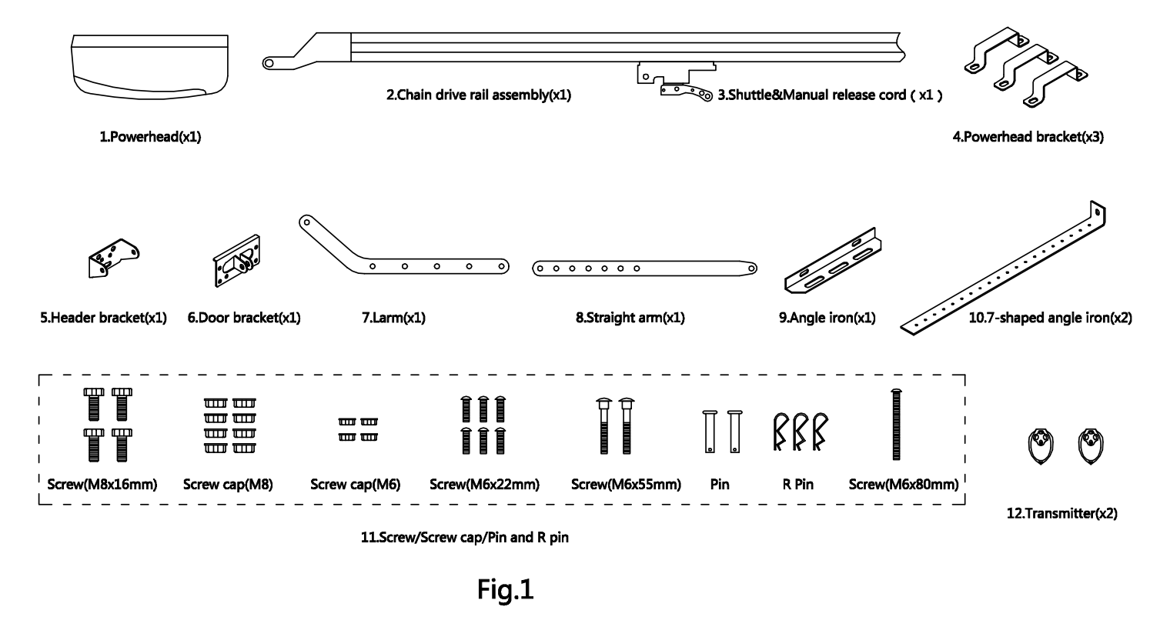5. Installation and adjustment 安装和调整

Step1步骤1
- Check the door is in good working condition, manually open and close the door to make sure the door operates smoothly and freely.检查车门是否处于良好的工作状态，手动开启和关闭车门，以确保车门平稳自由地运行。
- The door must be well balanced.门必须保持良好的平衡。
- Check to see if there is a solid frame in the wall above the center of the door.检查一下门中央的墙上是否有实框。
- Close the door.把门关上。
- Measure the door width, mark the centerline of the door using a pencil, and extend the line down to the door surface, then up the wall above the door.测量门的宽度，用铅笔标出门的中心线，把线一直延伸到门的表面，然后沿着门上方的墙向上。
- Check the installation height of the operator. Slowly open garage door and observe the highest point of door while moving. Close the door again and mark this highest point on the wall, mark a horizontal line across the vertical centerline around 40mm above the highest point. (Note: there should be 80mm space between this horizontal line to the ceiling. If there is not enough space, please use the max. height possible to allow the header bracket to be fitted properly. )检查操作员的安装高度。慢慢打开车库门，在移动时观察车门的最高点。再次关上门，并在墙上标出这个最高点，在最高点上方40mm左右的垂直中心线上划一条水平线。（注意：这条水平线与天花板之间应有80毫米的间隔。如果没有足够的空间，请使用最大值。高度可能允许适当地安装头架支架)。
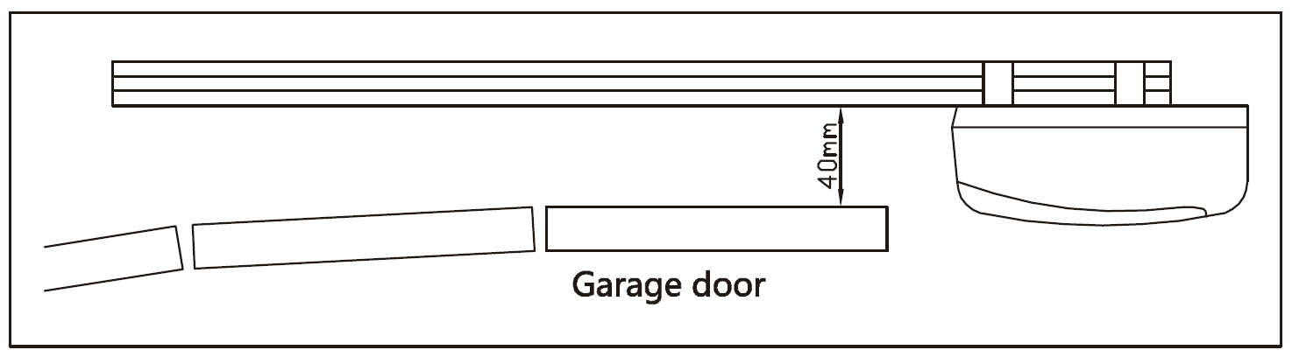
Fig.2
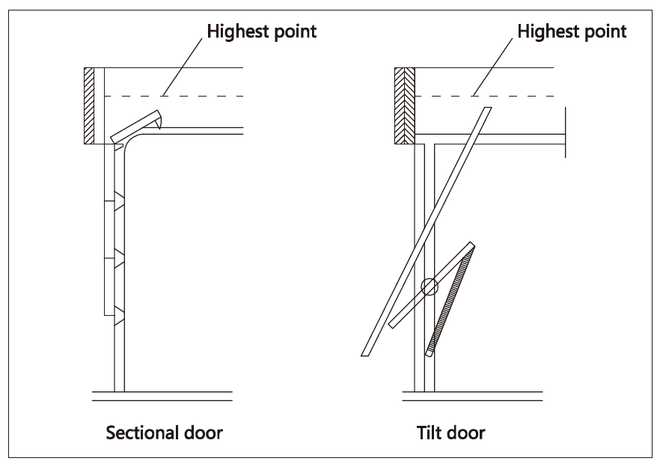
Fig.3
- Fit the header bracket to the wall above the door, the centerline of the door should align with the centerline of the bracket, The bottom edge of the bracket should align with the horizontal line. Fix the header bracket to the wall with expansion bolts.将头支架放在门上方的墙上，门的中心线应与支架的中心线对齐，支架的底边应与水平线对齐。用膨胀螺栓将头支架固定在墙上。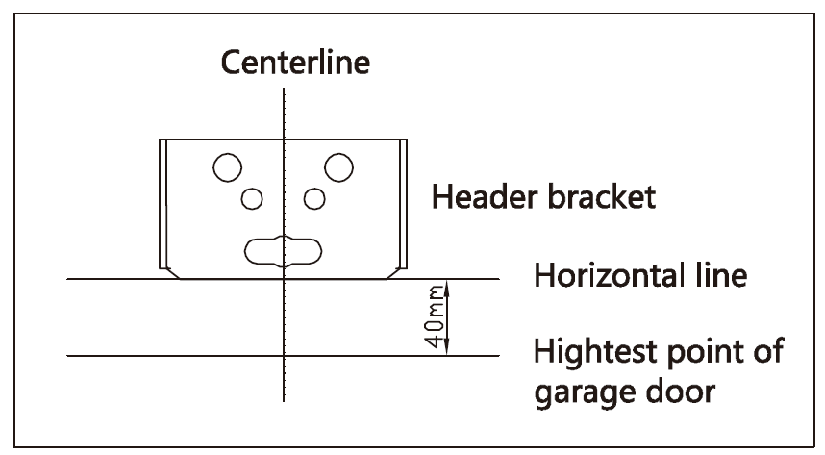

Fig.4

Step 2
- Insert the shuttle into the groove of the chain drive rail. Be sure it faces the right direction (the release arm on the shuttle towards the powerhead). Fasten the four screws (M6x22mm).将穿梭机插入链条传动轨道的凹槽。一定要朝正确的方向（穿梭机上的释放臂指向动力头）。紧固四个螺丝（m 6x22mm）。
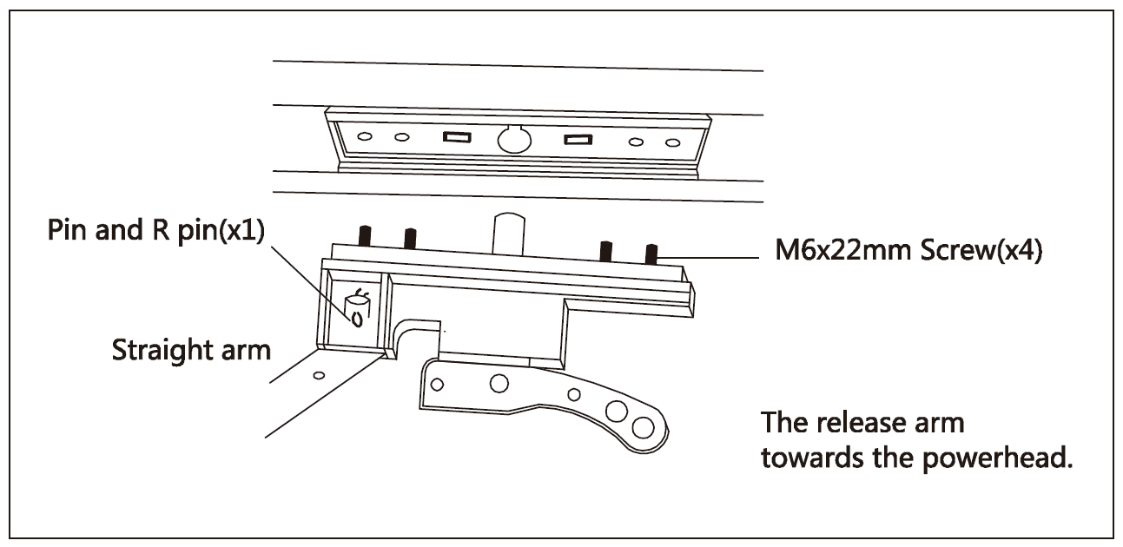
Fig.5

Step 3
- Place the powerhead on the floor, add cardboard packing to protect the powerhead from scratching by the floor. Attach the powerhead unit to the chain drive rail, make sure the spindle is inserted into the chain drive, then fix the brackets.将电机头放在地板上，加上纸板包装，防止电机头被地板刮伤。将动力头装置连接到链条驱动轨道上，确保主轴插入链条驱动，然后固定支架。
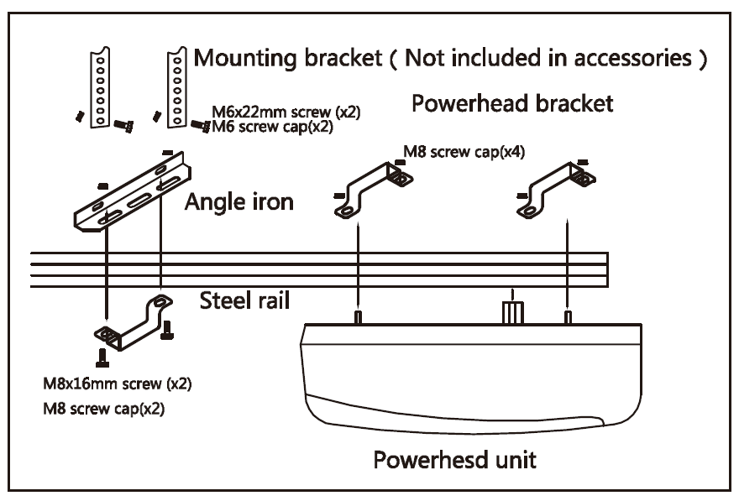

Fig.6

Step 4
- Close the door.把门关上。
- Place the operator in the center of the floor. Lift the front end of the rail up to the header bracket that has been mounted above the garage door, insert the bolt and secure it with nut see Fig.7.把操作员放在地板的中央。将导轨的前端抬起，直到安装在车库门上方的头支架，插入螺栓并用螺母固定，见图7。
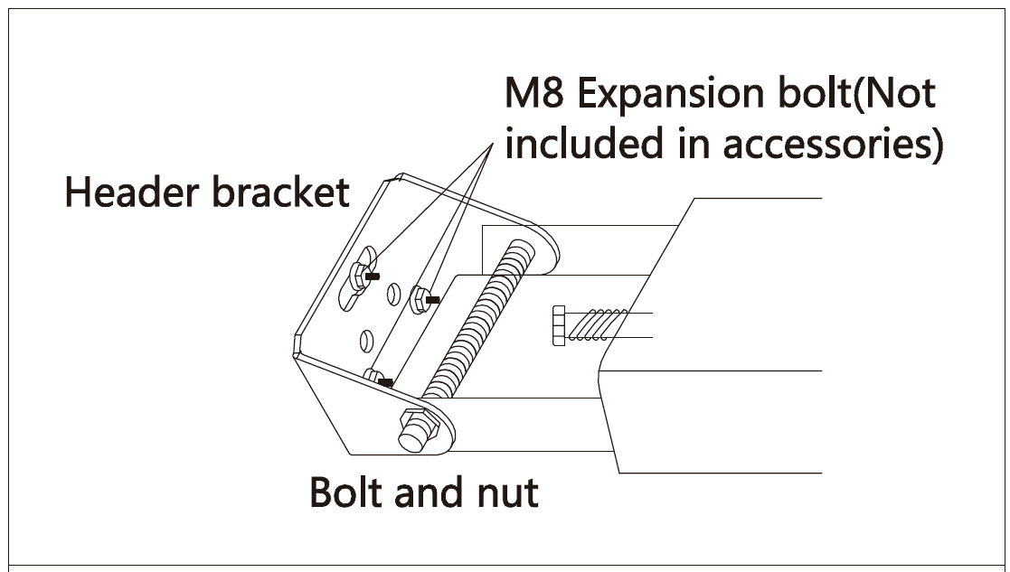

Fig.7

Step 5
- Raise and support the powerhead with a ladder and line up the rail with the centerline marked on the door. The rail must be level.用梯子扶起和支撑动力头，用门上标明的中心线在栏杆上排成一行。轨道必须是水平的。
- Fix the rail to ceiling with mounting brackets (not included in accessories) and angle iron see Fig.6, make sure that the rail is level. If necessary, Check the door does not touch any part of the rail by opening or closing it manually.用安装支架（不包括在附件中）将钢轨固定在天花板上，角铁见图6，确保钢轨水平。必要时，检查门没有接触轨道的任何部分，手动打开或关闭。
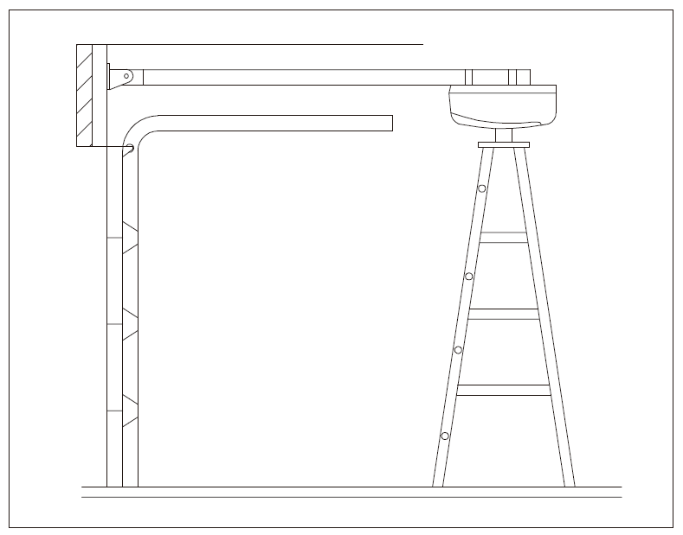
Fig.8

Step 6
Fix the door bracket on the top edge of the door with screws (M8X55) and screw caps (M8). Link the L arm to the door bracket with pin and R pin. Link the straight arm to the shuttle with pin and R pin, then connect L arm to straight arm with two screws (M8X16) and screw caps (M8), ensure the door arm can be moved freely. See Fig.8, Fig.9 and Fig.10.用螺丝（m6 x55）和螺丝帽（m6）固定门的顶部边缘的门架。用引脚和r引脚将l臂连接到门架上。用引脚和r引脚将直臂与航天飞机连接起来，然后用两个螺丝（m8 x16）和螺丝帽（m8）将l臂与直臂连接起来，确保门臂可以自由移动。见图8，图9和图10。
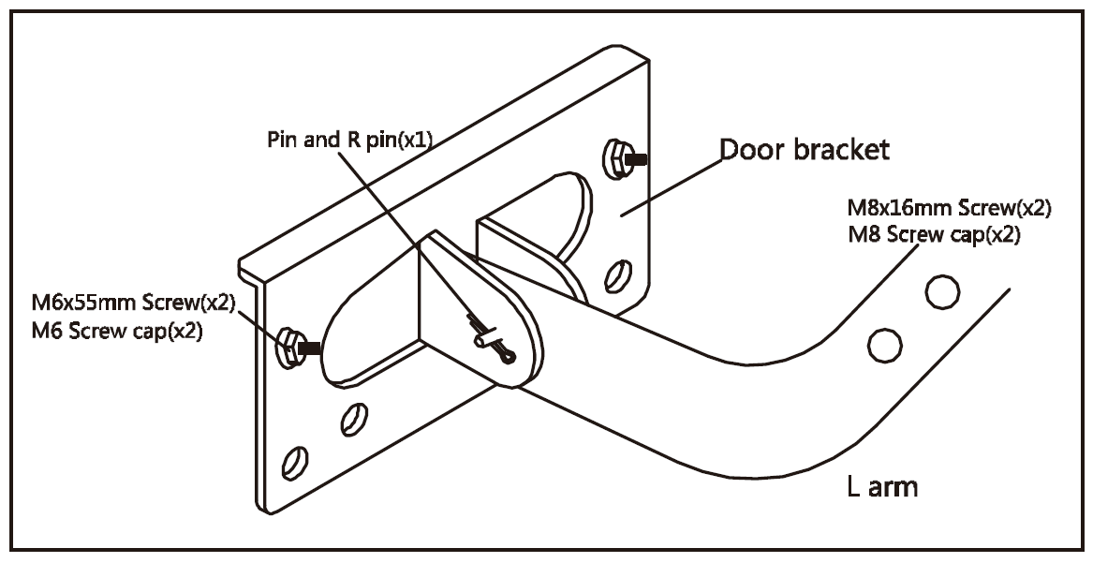

Fig.9

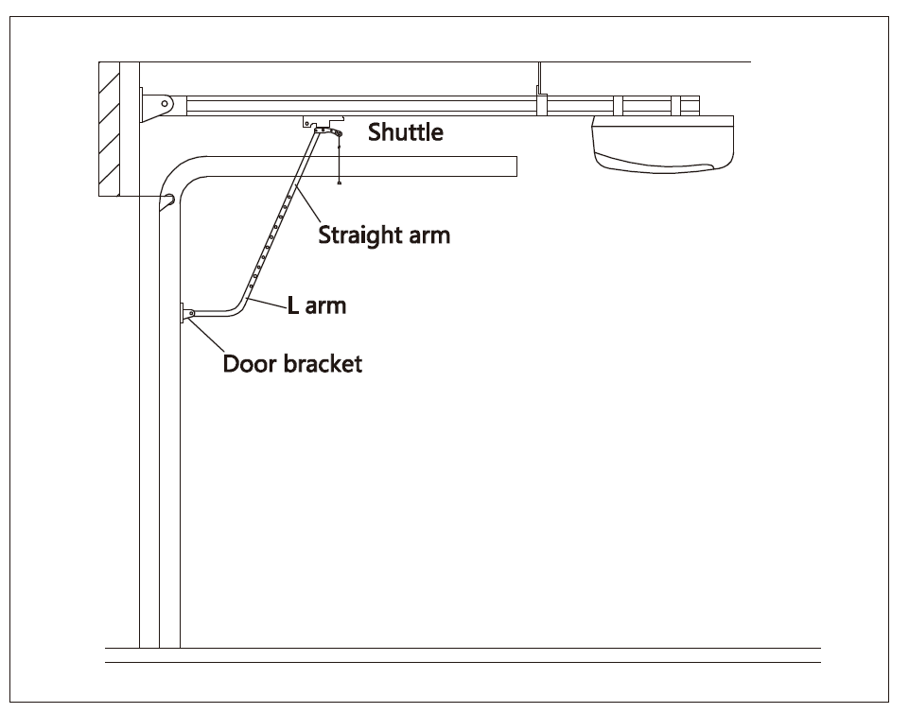
Fig.10
Manual operation
If the door has to be operated manually due to a power cut or malfunction of the automated system, pull the release rope, open and close the door manually. To reconnect the door, move the door by hand until it engages into the chain shuttle.手工操作
如果由于电力中断或自动系统故障，门必须手动操作，则拉释放绳，手动打开和关闭门。若要重新连接门，请用手移动门，直到它与链条穿梭机接合。

6. Programming 编程
SET button: Mode set and Confirm function设置按钮：模式设置和确认功能
LEARN button: Transmitter code set and clear function代码按钮：发射机代码集和清除功能
UP button: Up limit向上按钮：向上限制
DOWN button: Down limit下拉按钮：下拉限制
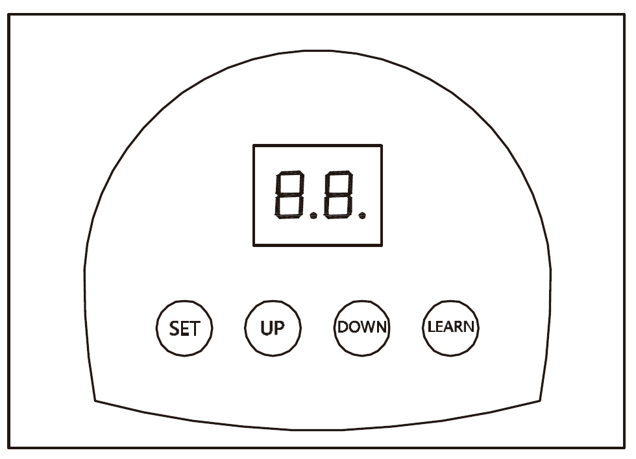

Fig.11

- With power on, the LED will display the number "88",when ‘ . ’ appears on the lower right corner of the LED display, the operator is now in normal state.
- .有了电源， LED会显示“88”的数字，LED右下角有<.>”出现在led显示器上时，操作员现在处于正常状态。
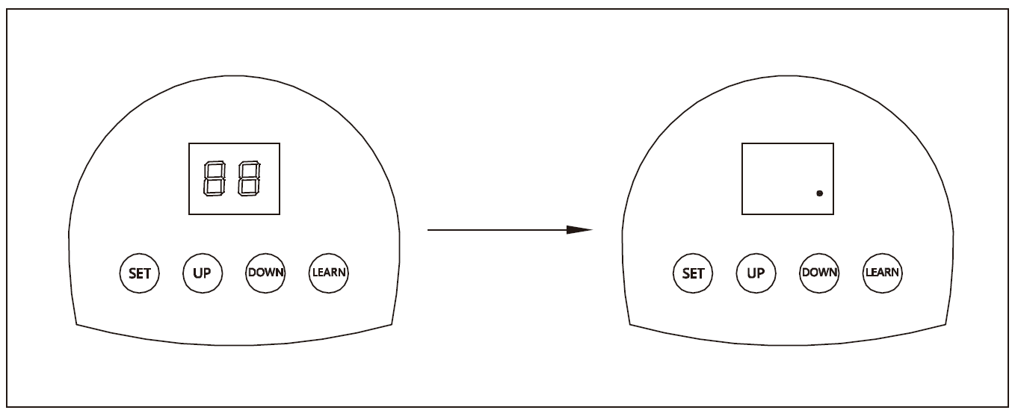Fig.12

Transmitter发射机
- Button 1, button 2, button 3: The remote control works in a single channel mode. With each press of the remote control button which has been programmed, the gate will open, stop, close or stop cycle.按钮1，按钮2，按钮3：遥控器在单一通道模式下工作。按下已设定的遥控器按钮，闸将会开启、停止、关闭或停止循环。
- Button 4: LOCK button按钮4：锁定按钮
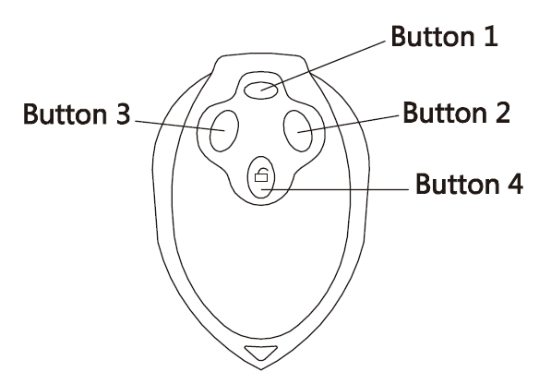
Fig.13

Adding extra transmitter (learn)增加额外的发射器(学习)
- Press the LEARN, ‘Su’ is indicated on the LED display.按下代码，“su”在led显示器上显示。
- Press the transmitter button which you want to use (button 1, 2, 3), then press the same button again.按下您要使用的传送器按钮（按钮1，2，3），然后再按同样的按钮。
- ‘Of’ on the LED display will flash.ed显示器上的su'会闪烁。
- ‘▬ 11’ is indicated on the LED display, then the learning process is finished.
Up to 30 transmitters may be used.<▬11>'标示在led显示上，然后学习过程就结束了。
可使用多达30个发报机。

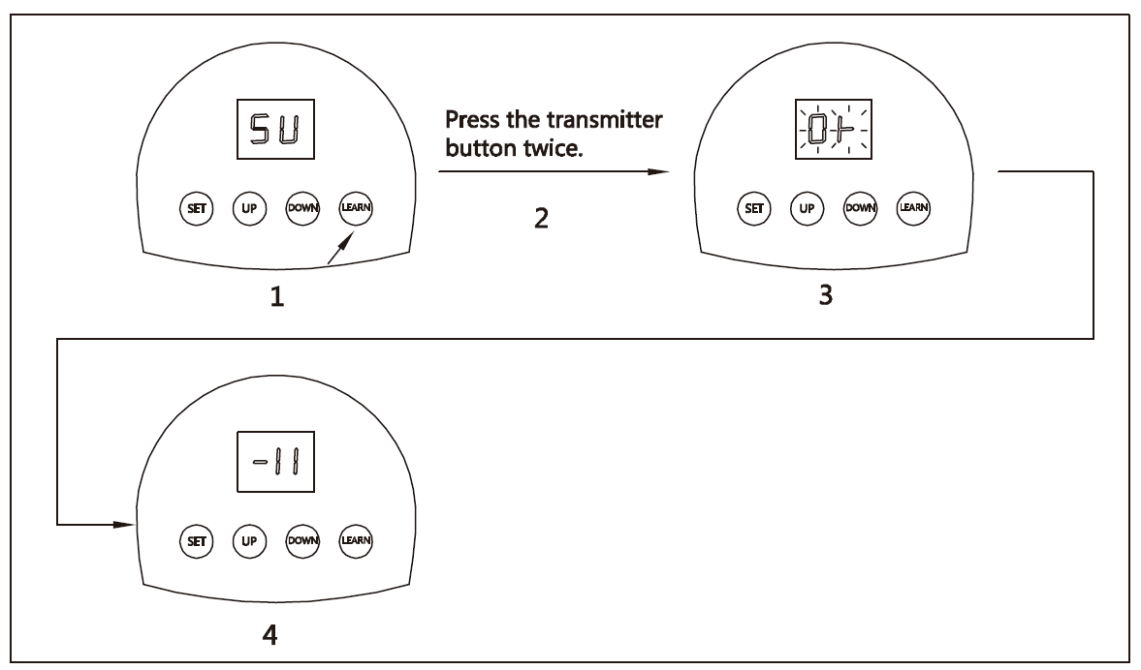

Fig.14

Deleting stored transmitters删除存储的发报机
- Press and hold LEARN, ‘▬11’ is indicated on the LED display.按下并按住代码，“▬11”在led显示器上显示。

2.After 8 seconds, the "DL" flickers and releases the button. All stored transmitters have been completely deleted
- 8秒后“dl”闪烁后松开按钮，所有储存的发射器已完全删除

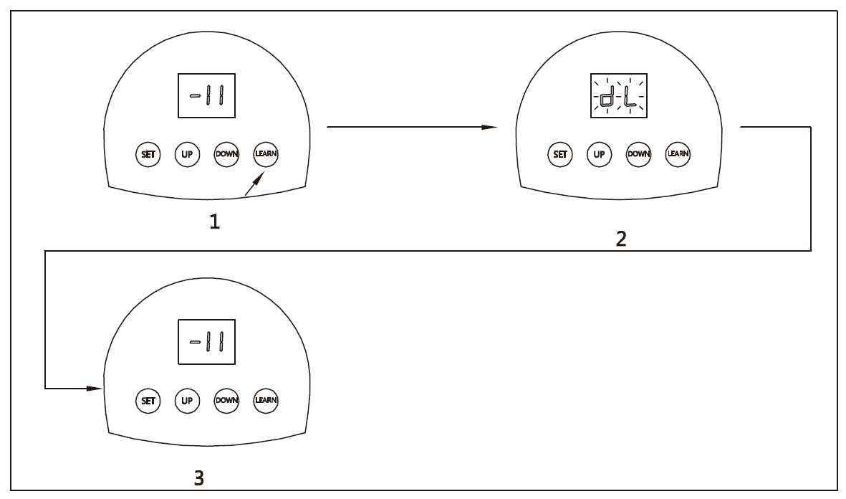Fig.15

Open and Close limit开放和关闭限制
- Press and hold SET four seconds until ‘P1’ is indicated on the LED display. The operator is now in programming mode..按下并按住设置4秒，直到“p1”显示在led显示器上。操作员现在处于编程模式。
- Press SET again, ‘OP’ is indicated on the LED display. 再次按下设置，“op”显示在led显示器上。
- Press and hold UP to set the open limit, ‘OP’ on the LED display will flash, release the button until the door has reached desired position.按并按住设置的开放限制，'op'上的led显示将闪光，释放按钮，直到门已经达到所需的位置。
- Press SET to confirm the open limit position, the LED will now indicated the ‘CL’.按下设置以确认开放限制位置，led现在会指示“cl”。
- Press and hold DOWN to set the close limit, ‘CL’ on the LED display will flash, release the button until the door has reached desired position.按下并按住设置的关闭限制，“cl”在led显示器上会闪动，松开按钮，直到车门达到预期的位置。
- Press SET to confirm the close limit position.按下设置以确认关闭限制位置。
- The door will now do a complete open & close cycle.门现在将做一个完整的开放和关闭循环。
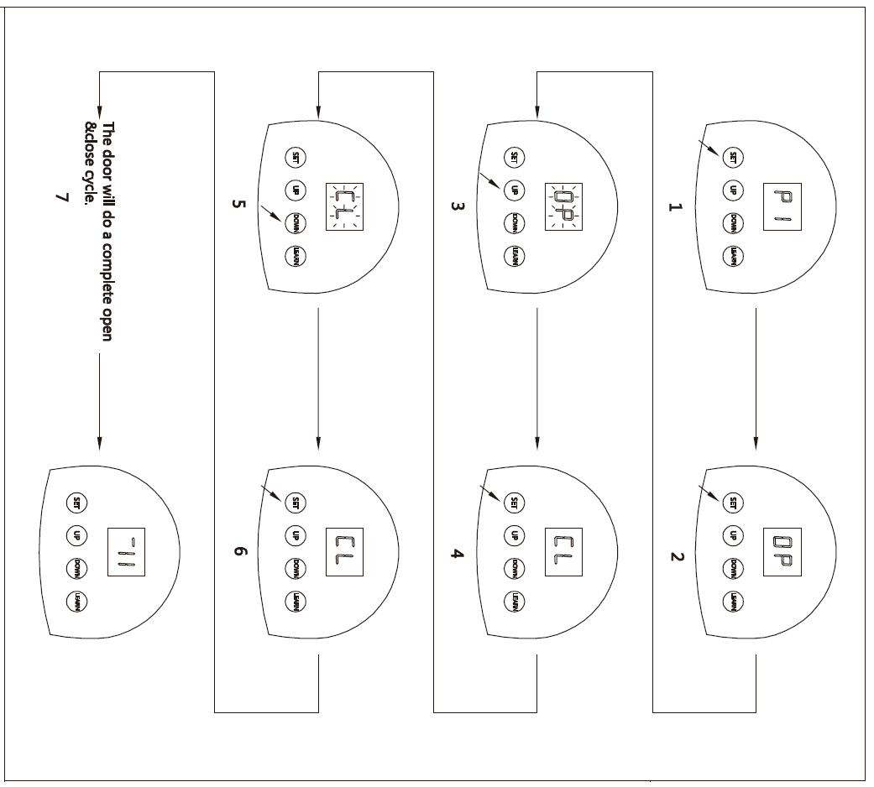
Fig.16

Adjusting obstruction force sensitivity
If the door meet an obstruction during closing, it will stop and reverse about 15cm~20cm.调节阻塞力灵敏度
如果关门时遇到障碍物，则会在15cm~20cm左右停车倒车。
- Press and hold SET four seconds until ‘P1’ is indicated on the LED display. .按下并按住设置4秒，直到“p1”显示在led显示器上。
- Press UP button, ‘P2’ is indicated on the LED display.按下向上按钮，“p2”指示在led显示器上。
- Press the SET, the unit is now in force adjustment mode. Note: the factory preset is F7.按下设定，单位现在处于强制调整模式。注：工厂预置为f7。
- Press UP to increase force setting, maximum force setting is level 9 (F9). Press DOWN to decrease force, minimum force setting is level 1(F1). .按下以增加力量设定，最大力量设定为9级（f9）。按下以减少力，最小力设定为1级（f1）。
- Press SET to confirm.按下设置确认。

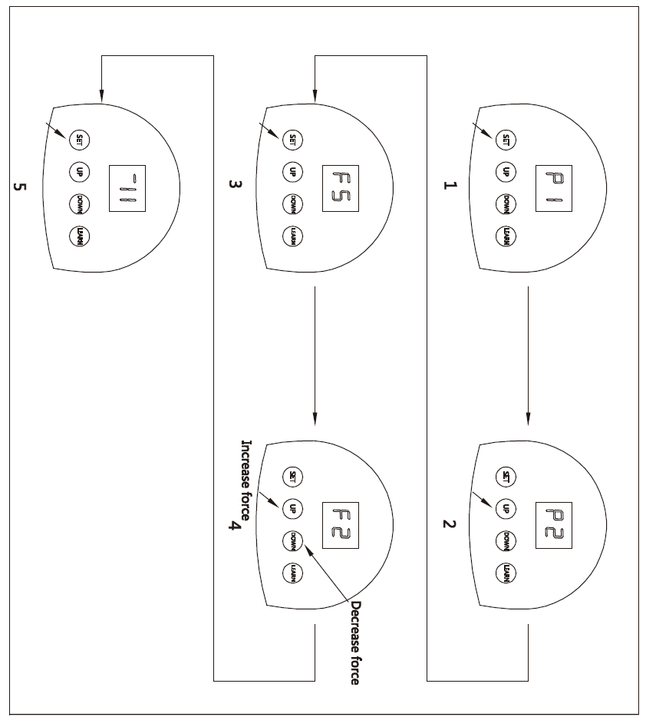Fig.17

Infrared photocell红外光电池
- Press and hold SET four seconds until ‘P1’ is indicated on the LED display.在led显示器上显示“p1”之前，按下并按住设置4秒。
- Press UP button twice until ‘P3’ is indicated on the LED display..按两次按钮，直到在led显示器上显示“p3”。
- Press the SET. The factory preset is ‘H0’.按下布景。工厂预置为“h 0”。
- Press UP (‘H1’ will display) to enable the photocell. Press DOWN (‘H0’ will display) to disable the photocell..按压（“h1”将显示）使光电池启用。按下（“h0”会显示）关闭光电池。
- Press SET to confirm the setting.按下设定以确认设定。
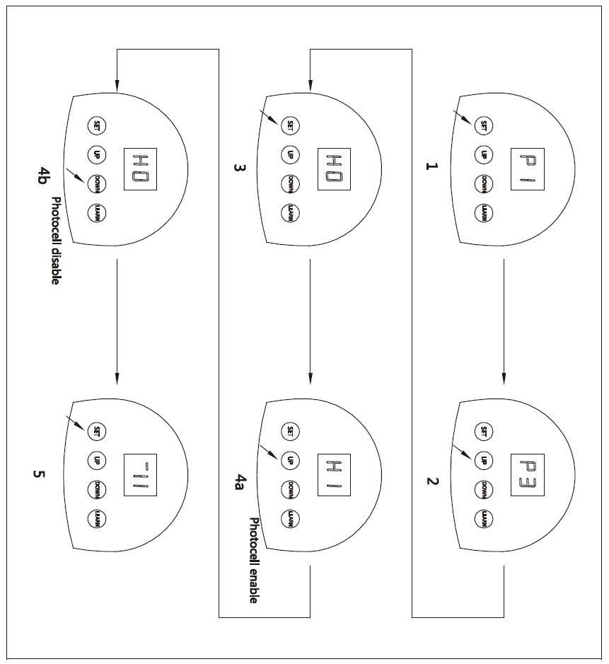 Fig.18

Automatic closing (1~9 minutes adjustable)自动关闭（可调节1~9分钟）
- Press and hold SET four seconds until ‘P1’ is indicated on the LED display.按下并按住设置4秒，直到“p1”显示在led显示器上。
- Press UP button three times until ‘P4’ is indicated on the LED display.按三次按钮，直到在led显示器上显示“p4”
- Press the SET. The factory preset is ‘b0’.按下布景。工厂预置为“b0”
- Press UP or DOWN to set auto close time (b0-b9). Press UP to increase timer, press DOWN to decrease timer. Note: To disable auto close set timer to ‘b0’.按上下设置自动关闭时间（b0-b9）。按下以增加定时器，按下以减少定时器。注意：禁用自动关闭设置计时器为“b0”。
- Press SET to confirm the setting.按下设定以确认设定。
NOTE: Automatic closing is available only when the door is in fully opened position.注意：只有当门处于完全打开的位置时，才可自动关闭。
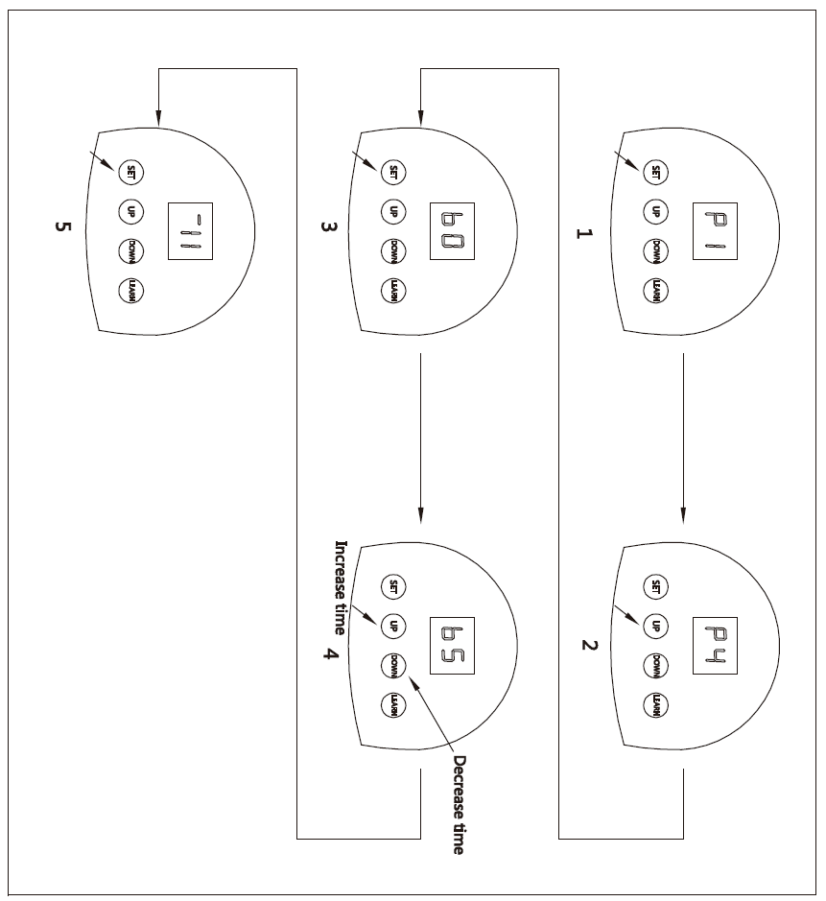Fig.19
Door lock mode
- Press and hold SET four seconds until ‘P1’ is indicated on the LED display.
- Press UP button four times until ‘P5’ is indicated on the LED display.
- Press the SET. The factory preset is ‘UL’.
- Press UP to enable the door lock (‘LC’ will display). Press DOWN to disable to door lock (‘UL’ will display).
- Press SET to confirm the setting.
- 门锁模式
1.按下并按住设置4秒，直到“p1”显示在led显示器上。
2.按四次按钮，直到在led显示器上显示“p5”。
3.按下布景。工厂的预置是“啊”。
4.按下按钮使门锁上（“lc”将显示）。按下关闭门锁（“ul”会显示）。
5.按下设定以确认设定。

NOTE: LOCK function is available only when the door is in fully closed position.
After setting DOOR LOCK function, the transmitter locked, you need press button 4 of transmitter to unlock, then press the other buttons to operate the door.
注意：锁功能只有在门完全关闭时才可用。
在设置了门锁功能后，发送器就上锁了，你需要按下发送器的4号按钮才能解锁，然后再按下其他按钮才能操作车门。
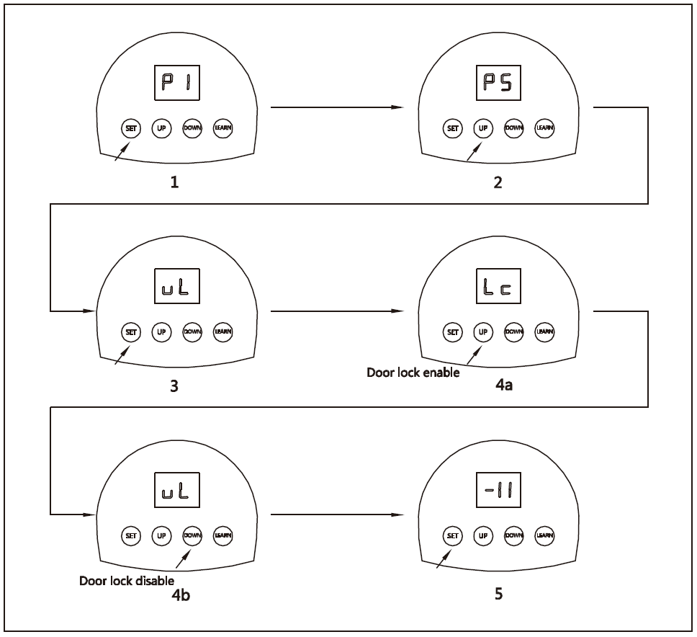Fig.20

7. External terminal connections 外部终端连接
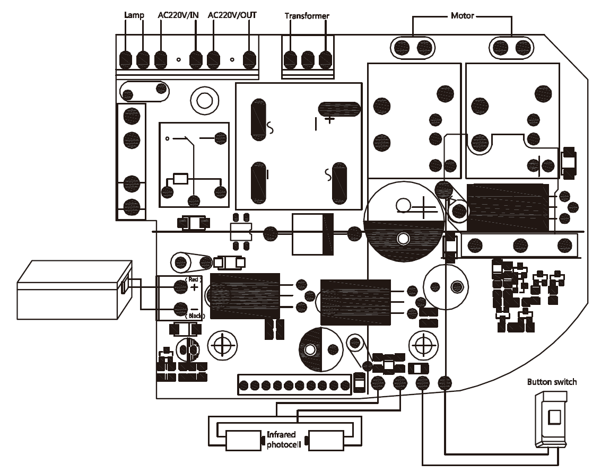Fig.21

8. Maintenance 维修
- Check the door once a month. The door should be carefully checked for balance. The door must be in good working order.每月检查一次门。门应该仔细检查以求平衡。门必须保持良好的工作状态。
- Check and add lubricant regularly.定期检查和添加润滑油。
- The auto-reverse function should be regularly inspected, and adjusted if necessary. For service, call an experienced serviceman.自动反转功能应定期检查，必要时进行调整。如果需要服务，打电话给有经验的军人。
- We suggest for safety reasons, photocells be used on all doors.为了安全起见，我们建议在所有的门上都使用光电池。
- Disconnect from mains supply before replacing bulb.更换灯泡前与电源断开连接。
- Be sure to read the entire manual before attempting to perform any installation or service to the door operator.在尝试对车门操作员执行任何安装或服务之前，一定要阅读整个手册。

9. Troubleshooting 故障排除
Trouble麻烦 | Possible causes可能的原因 | Solutions解决办法
The door fails to open and close. LED display does not light.门开不了也关不上。led显示器不发光。 | 1. Power is OFF.  2. Fuse blown.  1.停电了。  2.保险丝烧断了。 | 1. Make sure that power is ON.  2. Replace fuse.  1.一定要打开电源。  2.更换保险丝。
After program the open and close limit, the motor fails to work.  在设定了开启和关闭的限制之后，发动机就不能工作了。 | 1. The screws on the tachometer (on motor) are loose.  2. Open and close limit.  1.（发动机上）测速仪上的螺丝松了。  2.开放和关闭限制。 | 1. Tighten the two screws. See Fig.21  2.Reprogram the open and close limit.1.把两个螺丝拧紧。见图21  2.重新编程开放和关闭的限制。
The door can open, fails to close.门可以打开，但关不上。 | Infrared photocell function is enable, but the photocell has not been installed or infrared beam is obstructed.红外线光电池功能启用，但光电池尚未安装或红外线光束受阻。 | Make sure the infrared photocell function is disable. Remove obstructions or aligning the transmitter and receiver.确保红外光电池功能失效。移除障碍物或调整发射器和接收器。
Remote control does not work.遥控器不工作。 | 1. Battery level may be low.  2. Transmitter  1.电池水平可能很低。  2.发射机 | 1. Replace the battery inside the transmitter.  2.Re-program the transmitter.  1.更换发射器内的电池。  2.重新编程发送器。
The transmitter operating distance becomes short or indicator light on the transmitter begins to dim.发射器的工作距离变短或发射器上的指示灯开始变暗。 | Battery level may be low.  电池水平可能很低。 | Replace battery.  更换电池。

